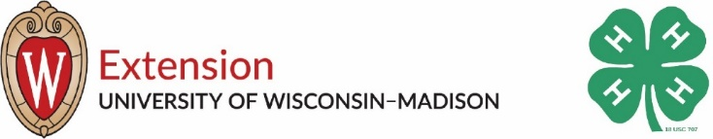

Racine County 4-H Volunteer Awards (2019-2020)

We have so many incredible volunteers in the Racine County 4-H program! Please take this opportunity to recognize Racine County volunteers for the awards listed below. Please fill out and return your nomination form by 4:30 p.m. on Monday, September 21st, 2020.

Your nominations may be dropped off in person at the Extension Racine County Office (1072 Milwaukee Avenue, Burlington, WI 53105) between 9:00 a.m.-12:00 p.m. or 1:00 p.m-3:00 p.m. by the stated date and time, placed in the green drop box in front of the office by the stated date and time, postmarked via USPS mail by the stated date, or emailed (beth.mattson@wisc.edu)/faxed (262-767-8775) timestamped by the stated date and time. Information not received by this date will not be considered for this year’s recognition and late forms are unable to be accepted.

Person Submitting Nomination:
Email:
Name of nominee (one nominee per submission):

I am nominating this person for: (Check all that apply)
4-H Volunteer of the Year
This volunteer award recognizes a 4-H volunteer who has had a positive impact on 4-H and 4-H youth on the club and county level for less than 10 years and who demonstrates exemplary service to 4-H while promoting service through volunteerism as both an opportunity and a privilege.
4-H Lifetime Volunteer of the Year
This volunteer award recognizes a 4-H volunteer who has had a positive impact on 4-H and 4-H youth on the club and county level for more than 10 years and who demonstrates exemplary service to 4-H while promoting service through volunteerism as both an opportunity and a privilege.
Friend of 4-H
The Friend of 4-H Award recognizes a volunteer, group, or organization who demonstrates exemplary service to and support of 4-H at the county level. Contributions or assistance provided by the nominee could be of an educational, financial, advisory, legislative, or other supportive nature.
4-H Community Servant Award
The Community Servant Award recognizes a 4-H member or 4-H group who demonstrates exemplary service to 4-H and their community through an ongoing commitment to community service and to making a positive impact on the community.
4-H Alumni Award
The 4-H Alumni Award is given to a past 4-H member who demonstrates active citizenship, leadership, and 4-H involvement.

In the space provided, give a brief description of the nominee’s qualifications for this award. Please reference the requirements for this award and include any other information that would be of interest to the selection committee.

