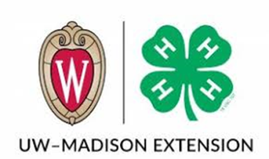
RACINE COUNTY 4-H
FUNDRAISER 2020

FOOD & CAR WASH CARD PICK-UP is Saturday, May 2nd at 8:00 A.M.
Please see your General Leader for the location.
FLOWER PICK-UP is Sunday, May 3rd from 9:00 A.M. to 1:00 P.M.
The location is Wayne’s Daughters Greenhouse at 2429 43rd St, Caledonia.
This fundraiser supports
Leadership: Ambassador Program, Summer Intern, National Youth Conference, Global Summit
Experiences: Madison, Atlanta, Washington D.C., American Spirit
Camps: Day, Base, Adventure, Winter, Space, Cloverbud Fun Day
Learning: Projects & programming, Arts & Craft Day, Rabbit Fun Day, Communications Arts Festival
Youth: Scholarships, Recognition Celebration, County Fair events, Holiday Ball, insurance and more!
We are selling:
Your family goal is $110 with a buyout option of $55.

Wayne’s Daughters’ Flowers 40% of sale to 4-H
Kwik Trip Car Wash Cards 45% of sale to 4-H
Screamin Sicilian Pizza 50% of sale to 4-H
RTS Cookies 55% of sale to 4-H*
*60% if county sells 1,000 cookie units!

Members: Your orders are due to your club fundraising coordinator by the end of March. Money is due on or before May 2nd to your club. Have checks written out to your club, except Raymond and Yorkville (they make payable to Racine County Leaders Association). To receive scholarships for school and experiences, members are expected to participate in the fundraisers.
Clubs: The county goal of this fundraiser is $70,400 in sales. The club goals will be given to General Leaders.
Your club receives: 6% of food sales if club meets its goal and county does not, and 8% of food sales if club and county both meet their goals.

General Leaders: Collect all forms and deliver to the Racine County UW-Extension Office (1072 Milwaukee Avenue
Burlington) no later than Thursday, April 1st, 2020, by 4:30 P.M. Your club’s forms may also be turned in at the Adult Leaders Association meeting on Monday, March 23rd, at 7:00 P.M.
Each club will write one check to the Racine County 4-H Leaders Association to be turned in on May 2nd. The checks will be held until May 18th.
Please Remember: Mark all of your sales sheets with your family name and club name.
Double check your math. Please use black or blue ink.
Thank you to everyone for helping to support your 4-H program.
Racine County 4-H is successful because of each of you!
If you have any questions, please call: Sam Johnson 414-232-2679 (leave a message) or Jenny Dabbs (262) 902-5252

