Racine County 4-H Car Wash Fundraiser 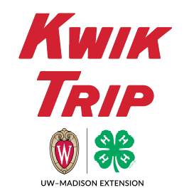
Club Name:_____________________________________ 4-H Family Name/Youth Name:______________________________________
Name / Address / Phone | # Cards  (5 ultimate washes) | X 36 | Total | Paid

Pick up will be on Saturday May 2nd @ 8 am. Location is the same as your clubs pizza pick-up.
Checks should be written out to your club (Yorkville or Raymond club members should write checks to Racine County 4-H Leaders Association).

