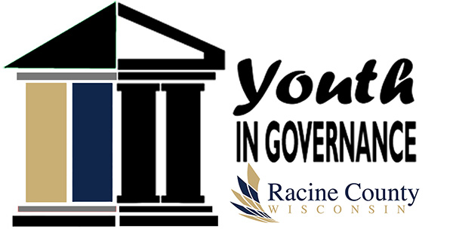
Racine County Youth in Governance
1072 Milwaukee Avenue
Burlington, WI 53105
262-767-2929
(FAX) 262-767-8775
RACINE COUNTY YOUTH IN GOVERNANCE
NOMINATION FORM (2020-2021)

Name of Adult Nominator: E-mail:______________________________________
Affiliation (i.e., school, church, organization, etc.):___________________________ Phone:______________________________________

 | Youth  First Name | Youth  Last Name | Youth  Street Address | City/Zip | School | Youth  E-Mail Address | Current Grade  (Please Circle)
 |  |  |  |  |  |  | 9 / 10 / 11
 |  |  |  |  |  |  | 9 / 10 / 11
 |  |  |  |  |  |  | 9 / 10 / 11
 |  |  |  |  |  |  | 9 / 10 / 11
 |  |  |  |  |  |  | 9 / 10 / 11
(Use additional pages if necessary.)

Please return completed form by Friday, December 13, 2019, to:

Racine County Youth in Governance
UW-Madison, Extension Racine County
1072 Milwaukee Avenue, Burlington, WI 53105
262-767-2929 phone | 262-767-8775 fax | 711 Wisconsin Relay
uwextension@racinecounty.com | http://racine.extension.wisc.edu

